《黑马旅游网》综合案例

前言
为了巩固web基础知识，提升综合运用能力，故而讲解此案例。要求，每位同学能够独立完成此案例。

项目导入
点击绿色＋按钮
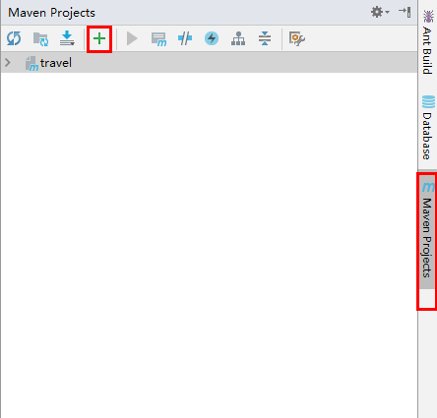
选择travel项目的pom.xml文件，点击ok，完成项目导入。需要等待一小会，项目初始化完成。
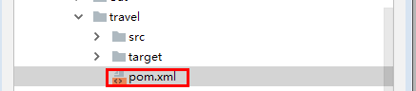

启动项目

方式一：
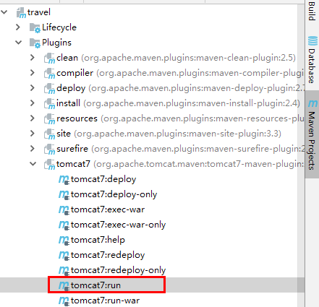

方式二：配置maven快捷启动
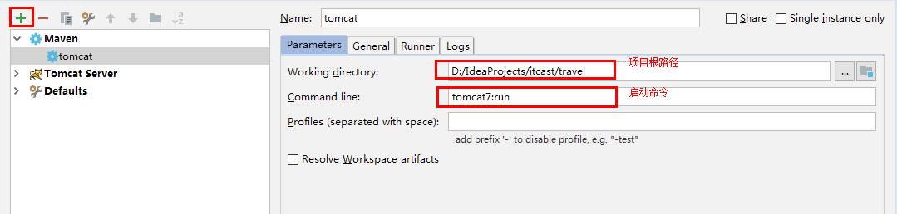
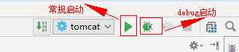

技术选型

Web层
  - Servlet：前端控制器
  - html：视图
  - Filter：过滤器
  - BeanUtils：数据封装
  - Jackson：json序列化工具

Service层
  - Javamail：java发送邮件工具
  - Redis：nosql内存数据库
  - Jedis：java的redis客户端

Dao层
  - Mysql：数据库
  - Druid：数据库连接池
  - JdbcTemplate：jdbc的工具

创建数据库
-- 创建数据库
CREATE DATABASE travel;
-- 使用数据库
USE travel;
--创建表
复制提供好的sql

注册功能

页面效果
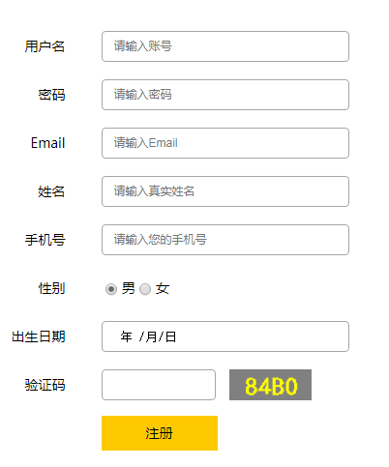

功能分析
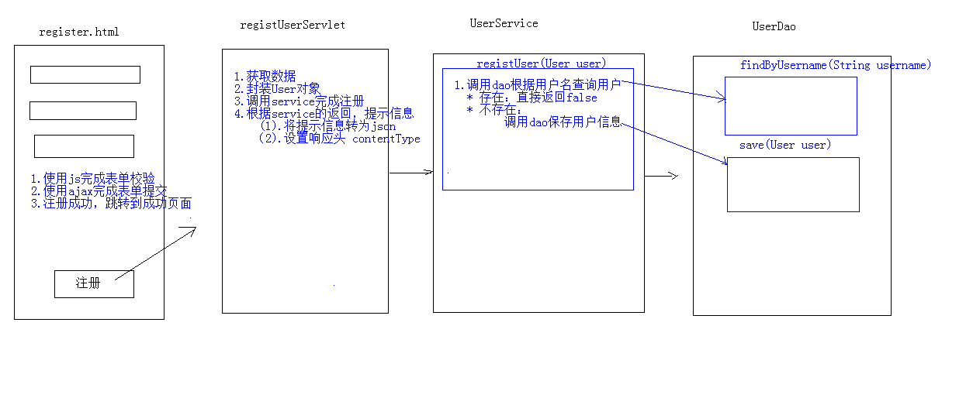

代码实现

前台代码实现

表单校验
提升用户体验，并减轻服务器压力。
//校验用户名
//单词字符，长度8到20位
function checkUsername() {
//1.获取用户名值
var username = $("#username").val();
//2.定义正则
var reg_username = /^\w{8,20}$/;
//3.判断，给出提示信息
var flag = reg_username.test(username);
if(flag){
//用户名合法
$("#username").css("border","");
}else{
//用户名非法,加一个红色边框
$("#username").css("border","1px solid red");
}
return flag;
}
//校验密码
function checkPassword() {
//1.获取密码值
var password = $("#password").val();
//2.定义正则
var reg_password = /^\w{8,20}$/;
//3.判断，给出提示信息
var flag = reg_password.test(password);
if(flag){
//密码合法
$("#password").css("border","");
}else{
//密码非法,加一个红色边框
$("#password").css("border","1px solid red");
}
return flag;
}
//校验邮箱
function checkEmail(){
//1.获取邮箱
var email = $("#email").val();
//2.定义正则 itcast@163.com
var reg_email = /^\w+@\w+\.\w+$/;
//3.判断
var flag = reg_email.test(email);
if(flag){
$("#email").css("border","");
}else{
$("#email").css("border","1px solid red");
}
return flag;
}
$(function () {
//当表单提交时，调用所有的校验方法
$("#registerForm").submit(function(){
return checkUsername() && checkPassword() && checkEmail();
//如果这个方法没有返回值，或者返回为true，则表单提交，如果返回为false，则表单不提交
});
//当某一个组件失去焦点是，调用对应的校验方法
$("#username").blur(checkUsername);
$("#password").blur(checkPassword);
$("#email").blur(checkEmail);
});

异步(ajax)提交表单
在此使用异步提交表单是为了获取服务器响应的数据。因为我们前台使用的是html作为视图层，不能够直接从servlet相关的域对象获取值，只能通过ajax获取响应数据
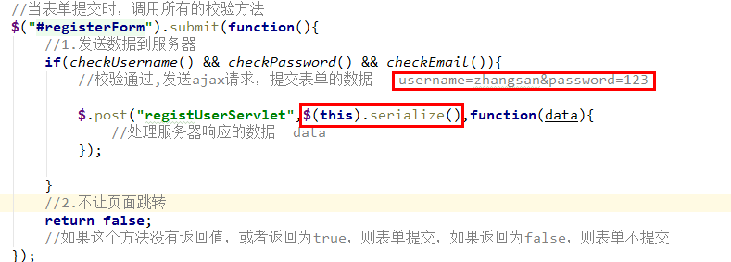

后台代码实现

编写RegistUserServlet
@WebServlet("/registUserServlet")
public class RegistUserServlet extends HttpServlet {
protected void doPost(HttpServletRequest request, HttpServletResponse response) throws ServletException, IOException {
//验证校验
String check = request.getParameter("check");
//从sesion中获取验证码
HttpSession session = request.getSession();
String checkcode_server = (String) session.getAttribute("CHECKCODE_SERVER");
session.removeAttribute("CHECKCODE_SERVER");//为了保证验证码只能使用一次
//比较
if(checkcode_server == null || !checkcode_server.equalsIgnoreCase(check)){
//验证码错误
ResultInfo info = new ResultInfo();
//注册失败
info.setFlag(false);
info.setErrorMsg("验证码错误");
//将info对象序列化为json
ObjectMapper mapper = new ObjectMapper();
String json = mapper.writeValueAsString(info);
response.setContentType("application/json;charset=utf-8");
response.getWriter().write(json);
return;
}
//1.获取数据
Map<String, String[]> map = request.getParameterMap();
//2.封装对象
User user = new User();
try {
BeanUtils.populate(user,map);
} catch (IllegalAccessException e) {
e.printStackTrace();
} catch (InvocationTargetException e) {
e.printStackTrace();
}
//3.调用service完成注册
UserService service = new UserServiceImpl();
boolean flag = service.regist(user);
ResultInfo info = new ResultInfo();
//4.响应结果
if(flag){
//注册成功
info.setFlag(true);
}else{
//注册失败
info.setFlag(false);
info.setErrorMsg("注册失败!");
}
//将info对象序列化为json
ObjectMapper mapper = new ObjectMapper();
String json = mapper.writeValueAsString(info);
//将json数据写回客户端
//设置content-type
response.setContentType("application/json;charset=utf-8");
response.getWriter().write(json);
}
protected void doGet(HttpServletRequest request, HttpServletResponse response) throws ServletException, IOException {
this.doPost(request, response);
}
}

编写UserService以及UserServiceImpl
public class UserServiceImpl implements UserService {
private UserDao userDao = new UserDaoImpl();
/**
* 注册用户
* @param user
* @return
*/
@Override
public boolean regist(User user) {
//1.根据用户名查询用户对象
User u = userDao.findByUsername(user.getUsername());
//判断u是否为null
if(u != null){
//用户名存在，注册失败
return false;
}
//2.保存用户信息
userDao.save(user);
return true;
}
}

编写UserDao以及UserDaoImpl
public class UserDaoImpl implements UserDao {
private JdbcTemplate template = new JdbcTemplate(JDBCUtils.getDataSource());
@Override
public User findByUsername(String username) {
User user = null;
try {
//1.定义sql
String sql = "select * from tab_user where username = ?";
//2.执行sql
user = template.queryForObject(sql, new BeanPropertyRowMapper<User>(User.class), username);
} catch (Exception e) {
}
return user;
}
@Override
public void save(User user) {
//1.定义sql
String sql = "insert into tab_user(username,password,name,birthday,sex,telephone,email) values(?,?,?,?,?,?,?)";
//2.执行sql
template.update(sql,user.getUsername(),
user.getPassword(),
user.getName(),
user.getBirthday(),
user.getSex(),
user.getTelephone(),
user.getEmail());
}
}

邮件激活
为什么要进行邮件激活？为了保证用户填写的邮箱是正确的。将来可以推广一些宣传信息，到用户邮箱中。

发送邮件
- 申请邮箱
- 开启授权码
- 在MailUtils中设置自己的邮箱账号和密码(授权码)
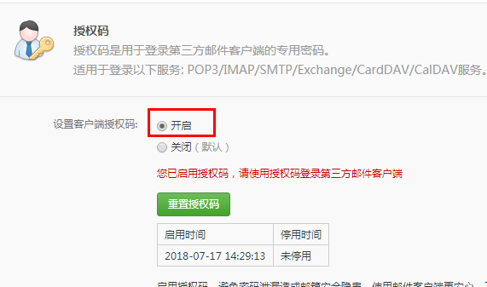

邮件工具类：MailUtils，调用其中sendMail方法可以完成邮件发送

用户点击邮件激活
经过分析，发现，用户激活其实就是修改用户表中的status为‘Y’
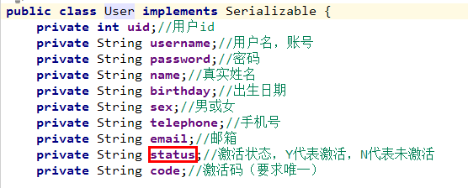

分析：
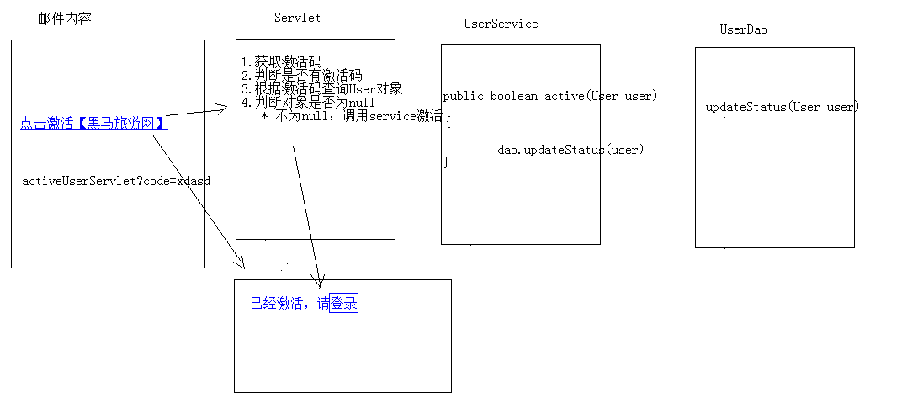

发送邮件代码：
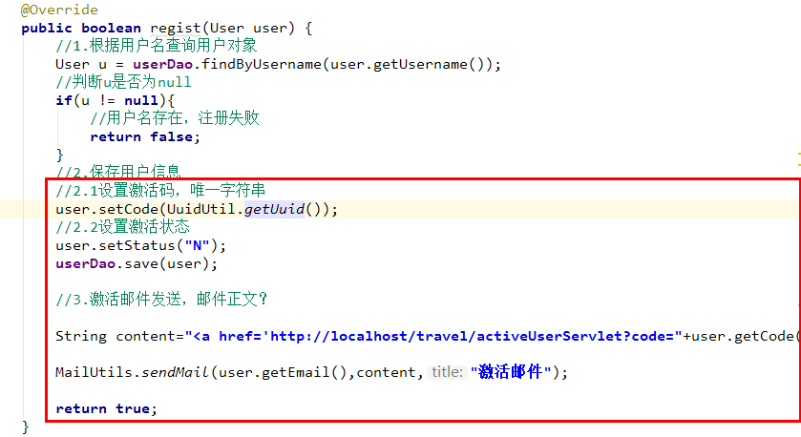

修改保存Dao代码，加上存储status和code 的代码逻辑
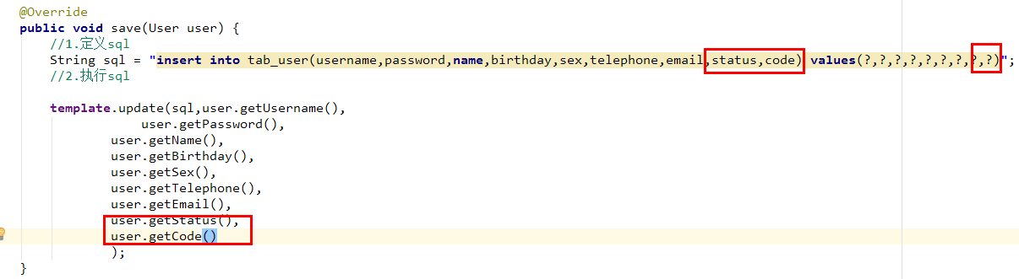

激活代码实现：
ActiveUserServlet
//1.获取激活码
String code = request.getParameter("code");
if(code != null){
//2.调用service完成激活
UserService service = new UserServiceImpl();
boolean flag = service.active(code);
//3.判断标记
String msg = null;
if(flag){
//激活成功
msg = "激活成功，请<a href='login.html'>登录</a>";
}else{
//激活失败
msg = "激活失败，请联系管理员!";
}
response.setContentType("text/html;charset=utf-8");
response.getWriter().write(msg);

UserService：active
@Override
public boolean active(String code) {
//1.根据激活码查询用户对象
User user = userDao.findByCode(code);
if(user != null){
//2.调用dao的修改激活状态的方法
userDao.updateStatus(user);
return true;
}else{
return false;
}
}

UserDao：findByCode updateStatus

/**
* 根据激活码查询用户对象
* @param code
* @return
*/
@Override
public User findByCode(String code) {
User user = null;
try {
String sql = "select * from tab_user where code = ?";
user = template.queryForObject(sql,new BeanPropertyRowMapper<User>(User.class),code);
} catch (DataAccessException e) {
e.printStackTrace();
}
return user;
}
/**
* 修改指定用户激活状态
* @param user
*/
@Override
public void updateStatus(User user) {
String sql = " update tab_user set status = 'Y' where uid=?";
template.update(sql,user.getUid());
}

登录

分析
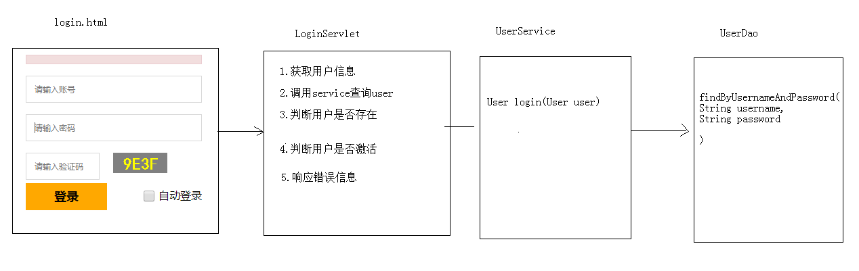

代码实现

前台代码
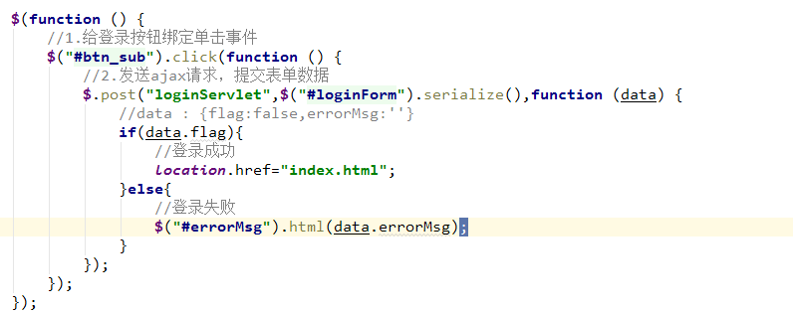

后台代码
LoginServlet
//1.获取用户名和密码数据
Map<String, String[]> map = request.getParameterMap();
//2.封装User对象
User user = new User();
try {
BeanUtils.populate(user,map);
} catch (IllegalAccessException e) {
e.printStackTrace();
} catch (InvocationTargetException e) {
e.printStackTrace();
}
//3.调用Service查询
UserService service = new UserServiceImpl();
User u = service.login(user);
ResultInfo info = new ResultInfo();
//4.判断用户对象是否为null
if(u == null){
//用户名密码或错误
info.setFlag(false);
info.setErrorMsg("用户名密码或错误");
}
//5.判断用户是否激活
if(u != null && !"Y".equals(u.getStatus())){
//用户尚未激活
info.setFlag(false);
info.setErrorMsg("您尚未激活，请激活");
}
//6.判断登录成功
if(u != null && "Y".equals(u.getStatus())){
//登录成功
info.setFlag(true);
}
//响应数据
ObjectMapper mapper = new ObjectMapper();
response.setContentType("application/json;charset=utf-8");
mapper.writeValue(response.getOutputStream(),info);

UserService
public User login(User user) {
return userDao.findByUsernameAndPassword(user.getUsername(),user.getPassword());
}

UserDao
public User findByUsernameAndPassword(String username, String password) {
User user = null;
try {
//1.定义sql
String sql = "select * from tab_user where username = ? and password = ?";
//2.执行sql
user = template.queryForObject(sql, new BeanPropertyRowMapper<User>(User.class), username,password);
} catch (Exception e) {
}
return user;
}

index页面中用户姓名的提示信息功能
效果：

header.html代码
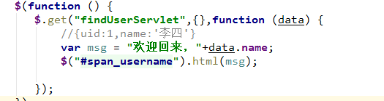
Servlet代码
//从session中获取登录用户
Object user = request.getSession().getAttribute("user");
//将user写回客户端
ObjectMapper mapper = new ObjectMapper();
response.setContentType("application/json;charset=utf-8");
mapper.writeValue(response.getOutputStream(),user);

退出
什么叫做登录了？session中有user对象。
实现步骤：
    - 访问servlet，将session销毁
    - 跳转到登录页面
代码实现：
Header.html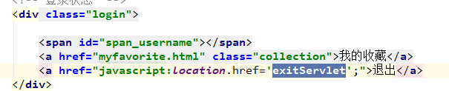
Servlet:
//1.销毁session
request.getSession().invalidate();
//2.跳转登录页面
response.sendRedirect(request.getContextPath()+"/login.html");

优化Servlet

目的
减少Servlet的数量，现在是一个功能一个Servlet，将其优化为一个模块一个Servlet，相当于在数据库中一张表对应一个Servlet，在Servlet中提供不同的方法，完成用户的请求。
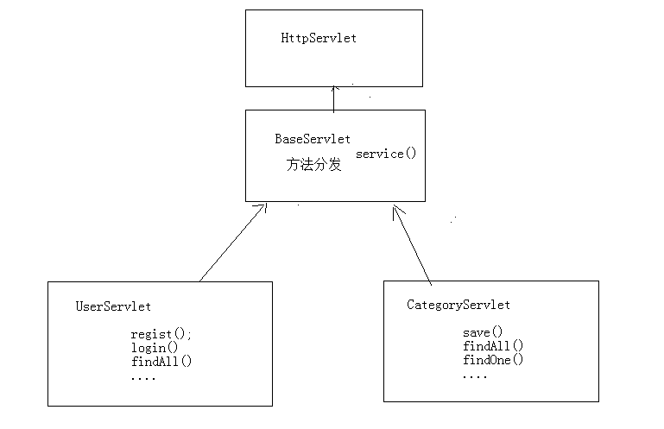

Idea控制台中文乱码解决：-Dfile.encoding=gb2312
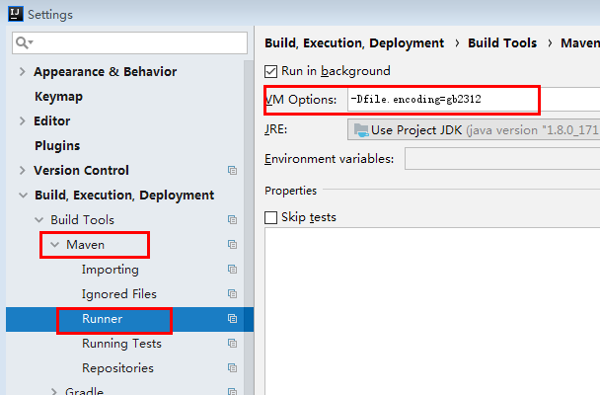

BaseServlet编写：
public class BaseServlet extends HttpServlet {
@Override
protected void service(HttpServletRequest req, HttpServletResponse resp) throws ServletException, IOException {
//System.out.println("baseServlet的service方法被执行了...");
//完成方法分发
//1.获取请求路径
String uri = req.getRequestURI(); // /travel/user/add
System.out.println("请求uri:"+uri);// /travel/user/add
//2.获取方法名称
String methodName = uri.substring(uri.lastIndexOf('/') + 1);
System.out.println("方法名称："+methodName);
//3.获取方法对象Method
//谁调用我？我代表谁
System.out.println(this);//UserServlet的对象cn.itcast.travel.web.servlet.UserServlet@4903d97e
try {
//获取方法
Method method = this.getClass().getMethod(methodName, HttpServletRequest.class, HttpServletResponse.class);
//4.执行方法
//暴力反射
//method.setAccessible(true);
method.invoke(this,req,resp);
} catch (NoSuchMethodException e) {
e.printStackTrace();
} catch (IllegalAccessException e) {
e.printStackTrace();
} catch (InvocationTargetException e) {
e.printStackTrace();
}
}
}

UserServlet改写
将之前的Servlet实现的功能，抽取到UserServlet中的不同方法中实现，并且将UserService创建抽取到成员变量位置
@WebServlet("/user/*") // /user/add /user/find
public class UserServlet extends BaseServlet {
//声明UserService业务对象
private UserService service = new UserServiceImpl();
/**
* 注册功能
* @param request
* @param response
* @throws ServletException
* @throws IOException
*/
public void regist(HttpServletRequest request, HttpServletResponse response) throws ServletException, IOException {
//验证校验
String check = request.getParameter("check");
//从sesion中获取验证码
HttpSession session = request.getSession();
String checkcode_server = (String) session.getAttribute("CHECKCODE_SERVER");
session.removeAttribute("CHECKCODE_SERVER");//为了保证验证码只能使用一次
//比较
if(checkcode_server == null || !checkcode_server.equalsIgnoreCase(check)){
//验证码错误
ResultInfo info = new ResultInfo();
//注册失败
info.setFlag(false);
info.setErrorMsg("验证码错误");
//将info对象序列化为json
ObjectMapper mapper = new ObjectMapper();
String json = mapper.writeValueAsString(info);
response.setContentType("application/json;charset=utf-8");
response.getWriter().write(json);
return;
}
//1.获取数据
Map<String, String[]> map = request.getParameterMap();
//2.封装对象
User user = new User();
try {
BeanUtils.populate(user,map);
} catch (IllegalAccessException e) {
e.printStackTrace();
} catch (InvocationTargetException e) {
e.printStackTrace();
}
//3.调用service完成注册
//UserService service = new UserServiceImpl();
boolean flag = service.regist(user);
ResultInfo info = new ResultInfo();
//4.响应结果
if(flag){
//注册成功
info.setFlag(true);
}else{
//注册失败
info.setFlag(false);
info.setErrorMsg("注册失败!");
}
//将info对象序列化为json
ObjectMapper mapper = new ObjectMapper();
String json = mapper.writeValueAsString(info);
//将json数据写回客户端
//设置content-type
response.setContentType("application/json;charset=utf-8");
response.getWriter().write(json);
}
/**
* 登录功能
* @param request
* @param response
* @throws ServletException
* @throws IOException
*/
public void login(HttpServletRequest request, HttpServletResponse response) throws ServletException, IOException {
//1.获取用户名和密码数据
Map<String, String[]> map = request.getParameterMap();
//2.封装User对象
User user = new User();
try {
BeanUtils.populate(user,map);
} catch (IllegalAccessException e) {
e.printStackTrace();
} catch (InvocationTargetException e) {
e.printStackTrace();
}
//3.调用Service查询
// UserService service = new UserServiceImpl();
User u = service.login(user);
ResultInfo info = new ResultInfo();
//4.判断用户对象是否为null
if(u == null){
//用户名密码或错误
info.setFlag(false);
info.setErrorMsg("用户名密码或错误");
}
//5.判断用户是否激活
if(u != null && !"Y".equals(u.getStatus())){
//用户尚未激活
info.setFlag(false);
info.setErrorMsg("您尚未激活，请激活");
}
//6.判断登录成功
if(u != null && "Y".equals(u.getStatus())){
request.getSession().setAttribute("user",u);//登录成功标记
//登录成功
info.setFlag(true);
}
//响应数据
ObjectMapper mapper = new ObjectMapper();
response.setContentType("application/json;charset=utf-8");
mapper.writeValue(response.getOutputStream(),info);
}
/**
* 查询单个对象
* @param request
* @param response
* @throws ServletException
* @throws IOException
*/
public void findOne(HttpServletRequest request, HttpServletResponse response) throws ServletException, IOException {
//从session中获取登录用户
Object user = request.getSession().getAttribute("user");
//将user写回客户端
ObjectMapper mapper = new ObjectMapper();
response.setContentType("application/json;charset=utf-8");
mapper.writeValue(response.getOutputStream(),user);
}
/**
* 退出功能
* @param request
* @param response
* @throws ServletException
* @throws IOException
*/
public void exit(HttpServletRequest request, HttpServletResponse response) throws ServletException, IOException {
//1.销毁session
request.getSession().invalidate();
//2.跳转登录页面
response.sendRedirect(request.getContextPath()+"/login.html");
}
/**
* 激活功能
* @param request
* @param response
* @throws ServletException
* @throws IOException
*/
public void active(HttpServletRequest request, HttpServletResponse response) throws ServletException, IOException {
//1.获取激活码
String code = request.getParameter("code");
if(code != null){
//2.调用service完成激活
//UserService service = new UserServiceImpl();
boolean flag = service.active(code);
//3.判断标记
String msg = null;
if(flag){
//激活成功
msg = "激活成功，请<a href='login.html'>登录</a>";
}else{
//激活失败
msg = "激活失败，请联系管理员!";
}
response.setContentType("text/html;charset=utf-8");
response.getWriter().write(msg);
}
}
}

页面路径改写
register.html
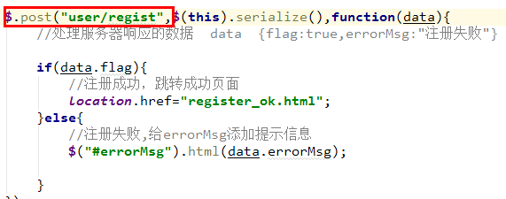
login.html
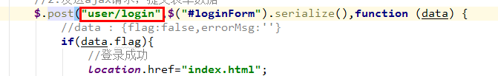
header.html
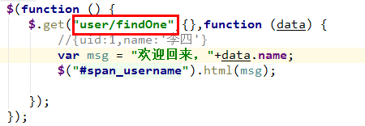
UserServiceImpl发送邮件
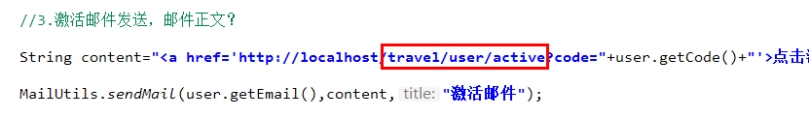

分类数据展示

效果：

分析：
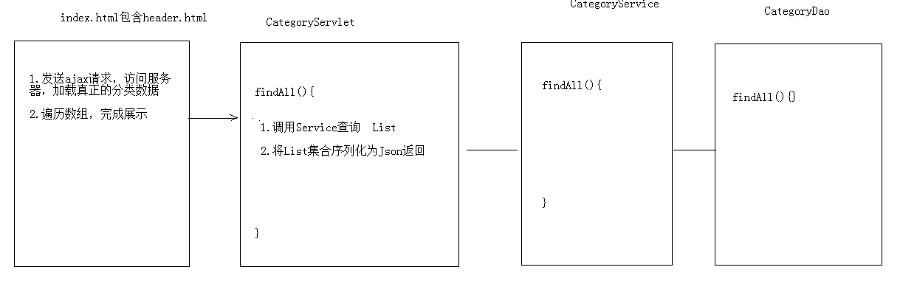

代码实现：

后台代码
CategoryServlet
@WebServlet("/category/*")
public class CategoryServlet extends BaseServlet {
private CategoryService service = new CategoryServiceImpl();
/**
* 查询所有
* @param request
* @param response
* @throws ServletException
* @throws IOException
*/
public void findAll(HttpServletRequest request, HttpServletResponse response) throws ServletException, IOException {
//1.调用service查询所有
List<Category> cs = service.findAll();
//2.序列化json返回
/* ObjectMapper mapper = new ObjectMapper();
response.setContentType("application/json;charset=utf-8");
mapper.writeValue(response.getOutputStream(),cs);*/
writeValue(cs,response);
}
}

CategoryService
public class CategoryServiceImpl implements CategoryService {
private CategoryDao categoryDao = new CategoryDaoImpl();
@Override
public List<Category> findAll() {
return categoryDao.findAll();
}
}

CategoryDao
public class CategoryDaoImpl implements CategoryDao {
private JdbcTemplate template = new JdbcTemplate(JDBCUtils.getDataSource());
@Override
public List<Category> findAll() {
String sql = "select * from tab_category ";
return template.query(sql,new BeanPropertyRowMapper<Category>(Category.class));
}
}

在BaseServlet中封装了序列化json的方法

/**
* 直接将传入的对象序列化为json，并且写回客户端
* @param obj
*/
public void writeValue(Object obj,HttpServletResponse response) throws IOException {
ObjectMapper mapper = new ObjectMapper();
response.setContentType("application/json;charset=utf-8");
mapper.writeValue(response.getOutputStream(),obj);
}
/**
* 将传入的对象序列化为json，返回
* @param obj
* @return
*/
public String writeValueAsString(Object obj) throws JsonProcessingException {
ObjectMapper mapper = new ObjectMapper();
return mapper.writeValueAsString(obj);
}

前台代码
hader.html加载后，发送ajax请求，请求category/findAll
//查询分类数据
$.get("category/findAll",{},function (data) {
//[{cid:1,cname:国内游},{},{}]
var lis = '<li class="nav-active"><a href="index.html">首页</a></li>';
//遍历数组,拼接字符串(<li>)
for (var i = 0; i < data.length; i++) {
var li = '<li><a href="route_list.html">'+data[i].cname+'</a></li>';
lis += li;
}
//拼接收藏排行榜的li,<li><a href="favoriterank.html">收藏排行榜</a></li>
lis+= '<li><a href="favoriterank.html">收藏排行榜</a></li>';
//将lis字符串，设置到ul的html内容中
$("#category").html(lis);
});

对分类数据进行缓存优化
分析发现，分类的数据在每一次页面加载后都会重新请求数据库来加载，对数据库的压力比较大，而且分类的数据不会经常产生变化，所有可以使用redis来缓存这个数据。
分析：
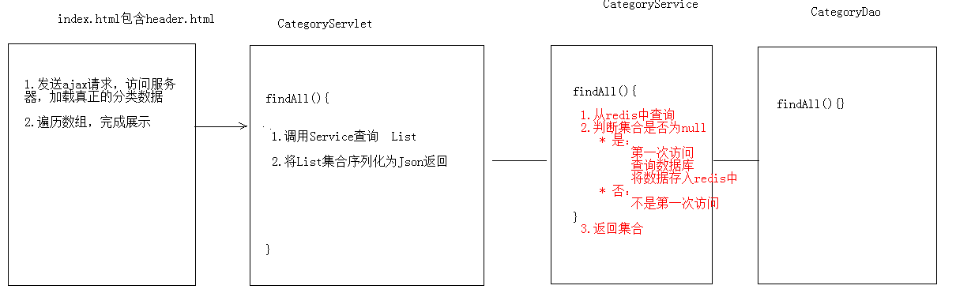

优化代码实现
期望数据中存储的顺序就是将来展示的顺序，使用redis的sortedset
@Override
public List<Category> findAll() {
//1.从redis中查询
//1.1获取jedis客户端
Jedis jedis = JedisUtil.getJedis();
//1.2可使用sortedset排序查询
Set<String> categorys = jedis.zrange("category", 0, -1);
List<Category> cs = null;
//2.判断查询的集合是否为空
if (categorys == null || categorys.size() == 0) {
System.out.println("从数据库查询....");
//3.如果为空,需要从数据库查询,在将数据存入redis
//3.1 从数据库查询
cs = categoryDao.findAll();
//3.2 将集合数据存储到redis中的 category的key
for (int i = 0; i < cs.size(); i++) {
jedis.zadd("category", cs.get(i).getCid(), cs.get(i).getCname());
}
} else {
System.out.println("从redis中查询.....");
//4.如果不为空,将set的数据存入list
cs = new ArrayList<Category>();
for (String name : categorys) {
Category category = new Category();
category.setCname(name);
cs.add(category);
}
}
return cs;
}

旅游线路的分页展示
点击了不同的分类后，将来看到的旅游线路不一样的。通过分析数据库表结构，发现，旅游线路表和分类表时一个多对一的关系
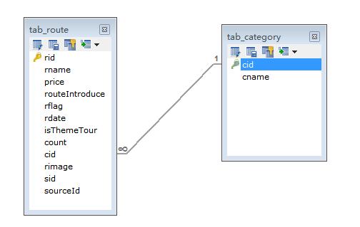
查询不同分类的旅游线路sql
Select * from tab_route where cid = ?;

类别id的传递
Redis中查询score（cid）
public class CategoryServiceImpl implements CategoryService {
private CategoryDao categoryDao = new CategoryDaoImpl();
@Override
public List<Category> findAll() {
//1.从redis中查询
//1.1获取jedis客户端
Jedis jedis = JedisUtil.getJedis();
//1.2可使用sortedset排序查询
//Set<String> categorys = jedis.zrange("category", 0, -1);
//1.3查询sortedset中的分数(cid)和值(cname)
Set<Tuple> categorys = jedis.zrangeWithScores("category", 0, -1);
List<Category> cs = null;
//2.判断查询的集合是否为空
if (categorys == null || categorys.size() == 0) {
System.out.println("从数据库查询....");
//3.如果为空,需要从数据库查询,在将数据存入redis
//3.1 从数据库查询
cs = categoryDao.findAll();
//3.2 将集合数据存储到redis中的 category的key
for (int i = 0; i < cs.size(); i++) {
jedis.zadd("category", cs.get(i).getCid(), cs.get(i).getCname());
}
} else {
System.out.println("从redis中查询.....");
//4.如果不为空,将set的数据存入list
cs = new ArrayList<Category>();
for (Tuple tuple : categorys) {
Category category = new Category();
category.setCname(tuple.getElement());
category.setCid((int)tuple.getScore());
cs.add(category);
}
}
return cs;
}
}

页面传递cid
header.html传递cid
var li = '<li><a href="route_list.html?cid='+data[i].cid+'">'+data[i].cname+'</a></li>';

获取cid

$(function () {
var search = location.search;
//alert(search);//?id=5
// 切割字符串，拿到第二个值
var cid = search.split("=")[1];
});

根据id查询不同类别的旅游线路数据
分页展示旅游线路数据：

分析
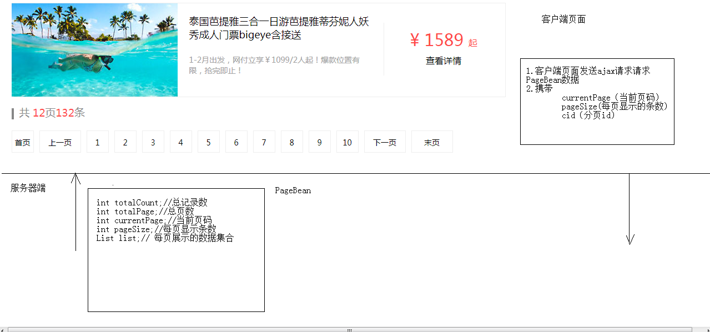

编码
- 客户端代码编写

$(function () {
var search = location.search;
// 切割字符串，拿到第二个值
var cid = search.split("=")[1];
//当页码加载完成后，调用load方法，发送ajax请求加载数据
load(cid);
});
function load(cid ,currentPage){
//发送ajax请求，请求route/pageQuery,传递cid
$.get("route/pageQuery",{cid:cid,currentPage:currentPage},function (pb) {
//解析pagebean数据，展示到页面上
//1.分页工具条数据展示
//1.1 展示总页码和总记录数
$("#totalPage").html(pb.totalPage);
$("#totalCount").html(pb.totalCount);
var lis = "";
var fristPage = '<li onclick="javascipt:load('+cid+')"><a href="javascript:void(0)">首页</a></li>';
//计算上一页的页码
var beforeNum = pb.currentPage - 1;
if(beforeNum <= 0){
beforeNum = 1;
}
var beforePage = '<li onclick="javascipt:load('+cid+','+beforeNum+')" class="threeword"><a href="javascript:void(0)">上一页</a></li>';
lis += fristPage;
lis += beforePage;
//1.2 展示分页页码
/*
1.一共展示10个页码，能够达到前5后4的效果
2.如果前边不够5个，后边补齐10个
3.如果后边不足4个，前边补齐10个
*/
// 定义开始位置begin,结束位置 end
var begin; // 开始位置
var end ; // 结束位置
//1.要显示10个页码
if(pb.totalPage < 10){
//总页码不够10页
begin = 1;
end = pb.totalPage;
}else{
//总页码超过10页
begin = pb.currentPage - 5 ;
end = pb.currentPage + 4 ;
//2.如果前边不够5个，后边补齐10个
if(begin < 1){
begin = 1;
end = begin + 9;
}
//3.如果后边不足4个，前边补齐10个
if(end > pb.totalPage){
end = pb.totalPage;
begin = end - 9 ;
}
}
for (var i = begin; i <= end ; i++) {
var li;
//判断当前页码是否等于i
if(pb.currentPage == i){
li = '<li class="curPage" onclick="javascipt:load('+cid+','+i+')"><a href="javascript:void(0)">'+i+'</a></li>';
}else{
//创建页码的li
li = '<li onclick="javascipt:load('+cid+','+i+')"><a href="javascript:void(0)">'+i+'</a></li>';
}
//拼接字符串
lis += li;
}
var lastPage = '<li class="threeword"><a href="javascript:;">末页</a></li>';
var nextPage = '<li class="threeword"><a href="javascript:;">下一页</a></li>';
lis += nextPage;
lis += lastPage;
//将lis内容设置到 ul
$("#pageNum").html(lis);
//2.列表数据展示
var route_lis = "";
for (var i = 0; i < pb.list.length; i++) {
//获取{rid:1,rname:"xxx"}
var route = pb.list[i];
var li = '<li>\n' +
' <div class="img"><img src="'+route.rimage+'" style="width: 299px;"></div>\n' +
' <div class="text1">\n' +
' <p>'+route.rname+'</p>\n' +
' <br/>\n' +
' <p>'+route.routeIntroduce+'</p>\n' +
' </div>\n' +
' <div class="price">\n' +
' <p class="price_num">\n' +
' <span>&yen;</span>\n' +
' <span>'+route.price+'</span>\n' +
' <span>起</span>\n' +
' </p>\n' +
' <p><a href="route_detail.html">查看详情</a></p>\n' +
' </div>\n' +
' </li>';
route_lis += li;
}
$("#route").html(route_lis);
//定位到页面顶部
window.scrollTo(0,0);
});
}

- 服务器端代码编写
  - 创建PageBean对象
public class PageBean<T> {
private int totalCount;//总记录数
private int totalPage;//总页数
private int currentPage;//当前页码
private int pageSize;//每页显示的条数
private List<T> list;//每页显示的数据集合
public int getTotalCount() {
return totalCount;
}
public void setTotalCount(int totalCount) {
this.totalCount = totalCount;
}
public int getTotalPage() {
return totalPage;
}
public void setTotalPage(int totalPage) {
this.totalPage = totalPage;
}
public int getCurrentPage() {
return currentPage;
}
public void setCurrentPage(int currentPage) {
this.currentPage = currentPage;
}
public int getPageSize() {
return pageSize;
}
public void setPageSize(int pageSize) {
this.pageSize = pageSize;
}
public List<T> getList() {
return list;
}
public void setList(List<T> list) {
this.list = list;
}
}
  - RouteServlet
@WebServlet("/route/*")
public class RouteServlet extends BaseServlet {
private RouteService routeService = new RouteServiceImpl();
/**
* 分页查询
* @param request
* @param response
* @throws ServletException
* @throws IOException
*/
public void pageQuery(HttpServletRequest request, HttpServletResponse response) throws ServletException, IOException {
//1.接受参数
String currentPageStr = request.getParameter("currentPage");
String pageSizeStr = request.getParameter("pageSize");
String cidStr = request.getParameter("cid");
int cid = 0;//类别id
//2.处理参数
if(cidStr != null && cidStr.length() > 0){
cid = Integer.parseInt(cidStr);
}
int currentPage = 0;//当前页码，如果不传递，则默认为第一页
if(currentPageStr != null && currentPageStr.length() > 0){
currentPage = Integer.parseInt(currentPageStr);
}else{
currentPage = 1;
}
int pageSize = 0;//每页显示条数，如果不传递，默认每页显示5条记录
if(pageSizeStr != null && pageSizeStr.length() > 0){
pageSize = Integer.parseInt(pageSizeStr);
}else{
pageSize = 5;
}
//3. 调用service查询PageBean对象
PageBean<Route> pb = routeService.pageQuery(cid, currentPage, pageSize);
//4. 将pageBean对象序列化为json，返回
writeValue(pb,response);
}
}

  - RouteService
public class RouteServiceImpl implements RouteService {
private RouteDao routeDao = new RouteDaoImpl();
@Override
public PageBean<Route> pageQuery(int cid, int currentPage, int pageSize) {
//封装PageBean
PageBean<Route> pb = new PageBean<Route>();
//设置当前页码
pb.setCurrentPage(currentPage);
//设置每页显示条数
pb.setPageSize(pageSize);
//设置总记录数
int totalCount = routeDao.findTotalCount(cid);
pb.setTotalCount(totalCount);
//设置当前页显示的数据集合
int start = (currentPage - 1) * pageSize;//开始的记录数
List<Route> list = routeDao.findByPage(cid,start,pageSize);
pb.setList(list);
//设置总页数 = 总记录数/每页显示条数
int totalPage = totalCount % pageSize == 0 ? totalCount / pageSize :(totalCount / pageSize) + 1 ;
pb.setTotalPage(totalPage);
return pb;
}
}

  - RouteDao
public class RouteDaoImpl implements RouteDao {
private JdbcTemplate template = new JdbcTemplate(JDBCUtils.getDataSource());
@Override
public int findTotalCount(int cid) {
String sql = "select count(*) from tab_route where cid = ?";
return template.queryForObject(sql,Integer.class,cid);
}
@Override
public List<Route> findByPage(int cid, int start, int pageSize) {
String sql = "select * from tab_route where cid = ? limit ? , ?";
return template.query(sql,new BeanPropertyRowMapper<Route>(Route.class),cid,start,pageSize);
}
}

旅游线路名称查询
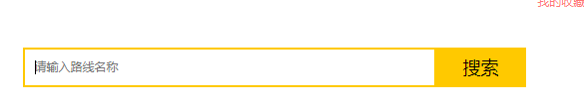

查询参数的传递
在header.html中
$("#search-button").click(function () {
//线路名称
var rname = $("#search_input").val();
var cid = getParameter("cid");
// 跳转路径 http://localhost/travel/route_list.html?cid=5，拼接上rname=xxx
location.href="http://localhost/travel/route_list.html?cid="+cid+"&rname="+rname;
});
在route_list.html
var cid = getParameter("cid");
//获取rname的参数值
var rname = getParameter("rname");
//判断rname如果不为null或者""
if(rname){
//url解码
rname = window.decodeURIComponent(rname);
}

修改后台代码
Servlet
@WebServlet("/route/*")
public class RouteServlet extends BaseServlet {
private RouteService routeService = new RouteServiceImpl();
/**
* 分页查询
* @param request
* @param response
* @throws ServletException
* @throws IOException
*/
public void pageQuery(HttpServletRequest request, HttpServletResponse response) throws ServletException, IOException {
//1.接受参数
String currentPageStr = request.getParameter("currentPage");
String pageSizeStr = request.getParameter("pageSize");
String cidStr = request.getParameter("cid");
//接受rname 线路名称
String rname = request.getParameter("rname");
rname = new String(rname.getBytes("iso-8859-1"),"utf-8");
int cid = 0;//类别id
//2.处理参数
if(cidStr != null && cidStr.length() > 0){
cid = Integer.parseInt(cidStr);
}
int currentPage = 0;//当前页码，如果不传递，则默认为第一页
if(currentPageStr != null && currentPageStr.length() > 0){
currentPage = Integer.parseInt(currentPageStr);
}else{
currentPage = 1;
}
int pageSize = 0;//每页显示条数，如果不传递，默认每页显示5条记录
if(pageSizeStr != null && pageSizeStr.length() > 0){
pageSize = Integer.parseInt(pageSizeStr);
}else{
pageSize = 5;
}
//3. 调用service查询PageBean对象
PageBean<Route> pb = routeService.pageQuery(cid, currentPage, pageSize,rname);
//4. 将pageBean对象序列化为json，返回
writeValue(pb,response);
}
}

Service
public PageBean<Route> pageQuery(int cid, int currentPage, int pageSize,String rname ) {
//封装PageBean
PageBean<Route> pb = new PageBean<Route>();
//设置当前页码
pb.setCurrentPage(currentPage);
//设置每页显示条数
pb.setPageSize(pageSize);
//设置总记录数
int totalCount = routeDao.findTotalCount(cid,rname);
pb.setTotalCount(totalCount);
//设置当前页显示的数据集合
int start = (currentPage - 1) * pageSize;//开始的记录数
List<Route> list = routeDao.findByPage(cid,start,pageSize,rname);
pb.setList(list);
//设置总页数 = 总记录数/每页显示条数
int totalPage = totalCount % pageSize == 0 ? totalCount / pageSize :(totalCount / pageSize) + 1 ;
pb.setTotalPage(totalPage);
return pb;
}

Dao

@Override
public int findTotalCount(int cid,String rname) {
//String sql = "select count(*) from tab_route where cid = ?";
//1.定义sql模板
String sql = "select count(*) from tab_route where 1=1 ";
StringBuilder sb = new StringBuilder(sql);
List params = new ArrayList();//条件们
//2.判断参数是否有值
if(cid != 0){
sb.append( " and cid = ? ");
params.add(cid);//添加？对应的值
}
if(rname != null && rname.length() > 0){
sb.append(" and rname like ? ");
params.add("%"+rname+"%");
}
sql = sb.toString();
return template.queryForObject(sql,Integer.class,params.toArray());
}
@Override
public List<Route> findByPage(int cid, int start, int pageSize,String rname) {
//String sql = "select * from tab_route where cid = ? and rname like ? limit ? , ?";
String sql = " select * from tab_route where 1 = 1 ";
//1.定义sql模板
StringBuilder sb = new StringBuilder(sql);
List params = new ArrayList();//条件们
//2.判断参数是否有值
if(cid != 0){
sb.append( " and cid = ? ");
params.add(cid);//添加？对应的值
}
if(rname != null && rname.length() > 0){
sb.append(" and rname like ? ");
params.add("%"+rname+"%");
}
sb.append(" limit ? , ? ");//分页条件
sql = sb.toString();
params.add(start);
params.add(pageSize);
return template.query(sql,new BeanPropertyRowMapper<Route>(Route.class),params.toArray());
}

修改前台代码

$(function () {
/* var search = location.search;
//alert(search);//?id=5
// 切割字符串，拿到第二个值
var cid = search.split("=")[1];*/
//获取cid的参数值
var cid = getParameter("cid");
//获取rname的参数值
var rname = getParameter("rname");
//判断rname如果不为null或者""
if(rname){
//url解码
rname = window.decodeURIComponent(rname);
}
//当页码加载完成后，调用load方法，发送ajax请求加载数据
load(cid,null,rname);
});
function load(cid ,currentPage,rname){
//发送ajax请求，请求route/pageQuery,传递cid
$.get("route/pageQuery",{cid:cid,currentPage:currentPage,rname:rname},function (pb) {
//解析pagebean数据，展示到页面上
//1.分页工具条数据展示
//1.1 展示总页码和总记录数
$("#totalPage").html(pb.totalPage);
$("#totalCount").html(pb.totalCount);
/*
<li><a href="">首页</a></li>
<li class="threeword"><a href="#">上一页</a></li>
<li class="curPage"><a href="#">1</a></li>
<li><a href="#">2</a></li>
<li><a href="#">3</a></li>
<li><a href="#">4</a></li>
<li><a href="#">5</a></li>
<li><a href="#">6</a></li>
<li><a href="#">7</a></li>
<li><a href="#">8</a></li>
<li><a href="#">9</a></li>
<li><a href="#">10</a></li>
<li class="threeword"><a href="javascript:;">下一页</a></li>
<li class="threeword"><a href="javascript:;">末页</a></li>
*/
var lis = "";
var fristPage = '<li onclick="javascipt:load('+cid+',1,\''+rname+'\')"><a href="javascript:void(0)">首页</a></li>';
//计算上一页的页码
var beforeNum = pb.currentPage - 1;
if(beforeNum <= 0){
beforeNum = 1;
}
var beforePage = '<li onclick="javascipt:load('+cid+','+beforeNum+',\''+rname+'\')" class="threeword"><a href="javascript:void(0)">上一页</a></li>';
lis += fristPage;
lis += beforePage;
//1.2 展示分页页码
/*
1.一共展示10个页码，能够达到前5后4的效果
2.如果前边不够5个，后边补齐10个
3.如果后边不足4个，前边补齐10个
*/
// 定义开始位置begin,结束位置 end
var begin; // 开始位置
var end ; // 结束位置
//1.要显示10个页码
if(pb.totalPage < 10){
//总页码不够10页
begin = 1;
end = pb.totalPage;
}else{
//总页码超过10页
begin = pb.currentPage - 5 ;
end = pb.currentPage + 4 ;
//2.如果前边不够5个，后边补齐10个
if(begin < 1){
begin = 1;
end = begin + 9;
}
//3.如果后边不足4个，前边补齐10个
if(end > pb.totalPage){
end = pb.totalPage;
begin = end - 9 ;
}
}
for (var i = begin; i <= end ; i++) {
var li;
//判断当前页码是否等于i
if(pb.currentPage == i){
li = '<li class="curPage" onclick="javascipt:load('+cid+','+i+',\''+rname+'\')"><a href="javascript:void(0)">'+i+'</a></li>';
}else{
//创建页码的li
li = '<li onclick="javascipt:load('+cid+','+i+',\''+rname+'\')"><a href="javascript:void(0)">'+i+'</a></li>';
}
//拼接字符串
lis += li;
}
/* for (var i = 1; i <= pb.totalPage ; i++) {
var li;
//判断当前页码是否等于i
if(pb.currentPage == i){
li = '<li class="curPage" onclick="javascipt:load('+cid+','+i+')"><a href="javascript:void(0)">'+i+'</a></li>';
}else{
//创建页码的li
li = '<li onclick="javascipt:load('+cid+','+i+')"><a href="javascript:void(0)">'+i+'</a></li>';
}
//拼接字符串
lis += li;
}*/
var lastPage = '<li class="threeword"><a href="javascript:;">末页</a></li>';
var nextPage = '<li class="threeword"><a href="javascript:;">下一页</a></li>';
lis += nextPage;
lis += lastPage;
//将lis内容设置到 ul
$("#pageNum").html(lis);
/*
<li>
<div class="img"><img src="images/04-search_03.jpg" alt=""></div>
<div class="text1">
<p>【减100元 含除夕/春节出发】广州增城三英温泉度假酒店/自由行套票</p>
<br/>
<p>1-2月出发，网付立享￥1099/2人起！爆款位置有限，抢完即止！</p>
</div>
<div class="price">
<p class="price_num">
<span>&yen;</span>
<span>299</span>
<span>起</span>
</p>
<p><a href="route_detail.html">查看详情</a></p>
</div>
</li>
*/
//2.列表数据展示
var route_lis = "";
for (var i = 0; i < pb.list.length; i++) {
//获取{rid:1,rname:"xxx"}
var route = pb.list[i];
var li = '<li>\n' +
' <div class="img"><img src="'+route.rimage+'" style="width: 299px;"></div>\n' +
' <div class="text1">\n' +
' <p>'+route.rname+'</p>\n' +
' <br/>\n' +
' <p>'+route.routeIntroduce+'</p>\n' +
' </div>\n' +
' <div class="price">\n' +
' <p class="price_num">\n' +
' <span>&yen;</span>\n' +
' <span>'+route.price+'</span>\n' +
' <span>起</span>\n' +
' </p>\n' +
' <p><a href="route_detail.html">查看详情</a></p>\n' +
' </div>\n' +
' </li>';
route_lis += li;
}
$("#route").html(route_lis);
//定位到页面顶部
window.scrollTo(0,0);
});
}

旅游线路的详情展示

分析


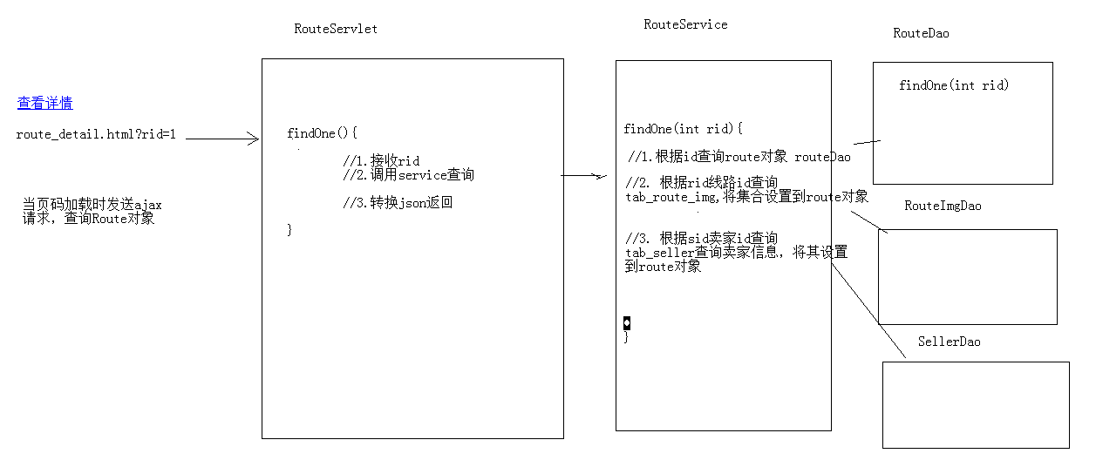

代码实现

后台代码
Servlet
/**
* 根据id查询一个旅游线路的详细信息
* @param request
* @param response
* @throws ServletException
* @throws IOException
*/
public void findOne(HttpServletRequest request, HttpServletResponse response) throws ServletException, IOException {
//1.接收id
String rid = request.getParameter("rid");
//2.调用service查询route对象
Route route = routeService.findOne(rid);
//3.转为json写回客户端
writeValue(route,response);
}

Service

@Override
public Route findOne(String rid) {
//1.根据id去route表中查询route对象
Route route = routeDao.findOne(Integer.parseInt(rid));
//2.根据route的id 查询图片集合信息
List<RouteImg> routeImgList = routeImgDao.findByRid(route.getRid());
//2.2将集合设置到route对象
route.setRouteImgList(routeImgList);
//3.根据route的sid（商家id）查询商家对象
Seller seller = sellerDao.findById(route.getSid());
route.setSeller(seller);
return route;
}

SellerDao

public class SellerDaoImpl implements SellerDao {
private JdbcTemplate template = new JdbcTemplate(JDBCUtils.getDataSource());
@Override
public Seller findById(int id) {
String sql = "select * from tab_seller where sid = ? ";
return template.queryForObject(sql,new BeanPropertyRowMapper<Seller>(Seller.class),id);
}
}
routeDao
@Override
public Route findOne(int rid) {
String sql = "select * from tab_route where rid = ?";
return template.queryForObject(sql,new BeanPropertyRowMapper<Route>(Route.class),rid);
}
RouteImgDao

public class RouteImgDaoImpl implements RouteImgDao {
private JdbcTemplate template = new JdbcTemplate(JDBCUtils.getDataSource());
@Override
public List<RouteImg> findByRid(int rid) {
String sql = "select * from tab_route_img where rid = ? ";
return template.query(sql,new BeanPropertyRowMapper<RouteImg>(RouteImg.class),rid);
}
}

前台代码
Route_detail.html中加载后
- 获取rid
- 发送ajax请求，获取route对象
- 解析对象的数据
//1.获取rid
var rid = getParameter("rid");
//2.发送请求请求 route/findOne
$.get("route/findOne",{rid:rid},function (route) {
//3.解析数据填充html
$("#rname").html(route.rname);
$("#routeIntroduce").html(route.routeIntroduce);
$("#price").html("¥"+route.price);
$("#sname").html(route.seller.sname);
$("#consphone").html(route.seller.consphone);
$("#address").html(route.seller.address);
//图片展示
var ddstr = '<a class="up_img up_img_disable"></a>';
//遍历routeImgList
for (var i = 0; i < route.routeImgList.length; i++) {
var astr ;
if(i >= 4){
astr = '<a title="" class="little_img" data-bigpic="'+route.routeImgList[i].bigPic+'" style="display:none;">\n' +
' <img src="'+route.routeImgList[i].smallPic+'">\n' +
' </a>';
}else{
astr = '<a title="" class="little_img" data-bigpic="'+route.routeImgList[i].bigPic+'">\n' +
' <img src="'+route.routeImgList[i].smallPic+'">\n' +
' </a>';
}
ddstr += astr;
}
ddstr+='<a class="down_img down_img_disable" style="margin-bottom: 0;"></a>';
$("#dd").html(ddstr);
//图片展示和切换代码调用
goImg();
});

旅游线路收藏功能

分析

判断当前登录用户是否收藏过该线路
当页面加载完成后，发送ajax请求，获取用户是否收藏的标记
根据标记，展示不同的按钮样式

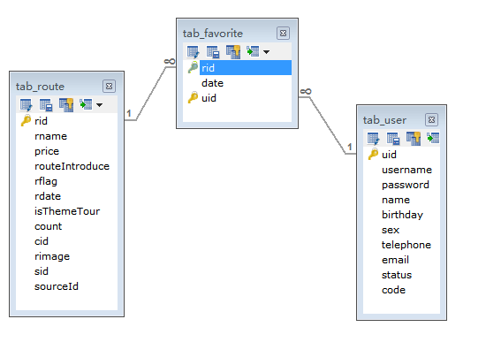

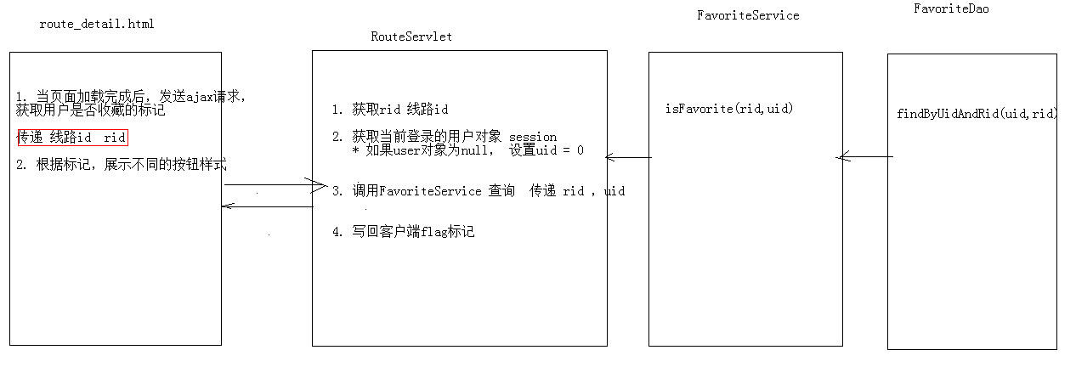

编写代码

后台代码
RouteServlet：

public void isFavorite(HttpServletRequest request, HttpServletResponse response) throws ServletException, IOException {
//1. 获取线路id
String rid = request.getParameter("rid");
//2. 获取当前登录的用户 user
User user = (User) request.getSession().getAttribute("user");
int uid;//用户id
if(user == null){
//用户尚未登录
uid = 0;
}else{
//用户已经登录
uid = user.getUid();
}
//3. 调用FavoriteService查询是否收藏
boolean flag = favoriteService.isFavorite(rid, uid);
//4. 写回客户端
writeValue(flag,response);
}

FavoriteService

@Override
public boolean isFavorite(String rid, int uid) {
Favorite favorite = favoriteDao.findByRidAndUid(Integer.parseInt(rid), uid);
return favorite != null;//如果对象有值，则为true，反之，则为false
}

FavoriteDao
@Override
public Favorite findByRidAndUid(int rid, int uid) {
Favorite favorite = null;
try {
String sql = " select * from tab_favorite where rid = ? and uid = ?";
favorite = template.queryForObject(sql, new BeanPropertyRowMapper<Favorite>(Favorite.class), rid, uid);
} catch (DataAccessException e) {
e.printStackTrace();
}
return favorite;
}

前台代码
route_detail.html

$(function () {
// 发送请求，判断用户是否收藏过该线路
var rid = getParameter("rid");
$.get("route/isFavorite",{rid:rid},function (flag) {
if(flag){
// 用户已经收藏过
//<a class="btn already" disabled="disabled">
//设置收藏按钮的样式
$("#favorite").addClass("already");
$("#favorite").prop("disabled",disabled);
}else{
// 用户没有收藏
}
});

收藏次数的动态展示
前台：
//设置收藏次数
$("#favoriteCount").html("已收藏"+route.count+"次");

后台：
RouteService
//4. 查询收藏次数
int count = favoriteDao.findCountByRid(route.getRid());
route.setCount(count);

FavoriteDao
@Override
public int findCountByRid(int rid) {
String sql = "SELECT COUNT(*) FROM tab_favorite WHERE rid = ?";
return template.queryForObject(sql,Integer.class,rid);
}

点击按钮收藏线路

分析：
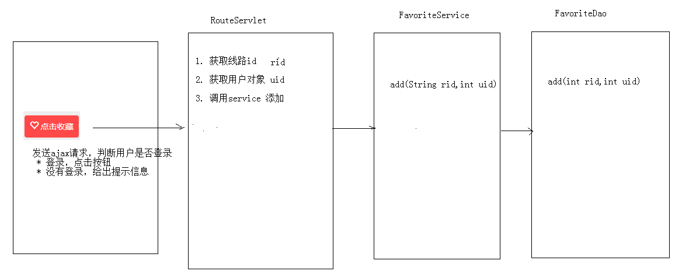

编码
前台代码
$(function () {
// 发送请求，判断用户是否收藏过该线路
var rid = getParameter("rid");
$.get("route/isFavorite",{rid:rid},function (flag) {
if(flag){
// 用户已经收藏过
//<a class="btn already" disabled="disabled">
//设置收藏按钮的样式
$("#favorite").addClass("already");
$("#favorite").attr("disabled","disabled");
//删除按钮的点击事件
$("#favorite").removeAttr("onclick");
}else{
// 用户没有收藏
}
});
});
//点击收藏按钮触发的方法
function addFavorite(){
var rid = getParameter("rid");
//1. 判断用户是否登录
$.get("user/findOne",{},function (user) {
if(user){
//用户登录了
//添加功能
$.get("route/addFavorite",{rid:rid},function () {
//代码刷新页面
location.reload();
});
}else{
//用户没有登录
alert("您尚未登录，请登录");
location.href="http://localhost/travel/login.html";
}
})
}

后台代码
RouteServlet
public void addFavorite(HttpServletRequest request, HttpServletResponse response) throws ServletException, IOException {
//1. 获取线路rid
String rid = request.getParameter("rid");
//2. 获取当前登录的用户
User user = (User) request.getSession().getAttribute("user");
int uid;//用户id
if(user == null){
//用户尚未登录
return ;
}else{
//用户已经登录
uid = user.getUid();
}
//3. 调用service添加
favoriteService.add(rid,uid);
}

FavoriteService
@Override
public void add(String rid, int uid) {
favoriteDao.add(Integer.parseInt(rid),uid);
}

FavoriteDao
@Override
public void add(int rid, int uid) {
String sql = "insert into tab_favorite values(?,?,?)";
template.update(sql,rid,new Date(),uid);
}

